A Case Study
On
Student Hostel Management System
Submitted partial fulfillment of the requirement of
Software Engineering (BIT 354CO)

Submitted By:
Sushant Thapa (Roll No: 40)
Submitted To:
Ananta Bhadra Lamichhane
KANTIPUR CITY COLLEGE
Putalisadak, Kathmandu
August, 2026

Acknowledgement
The developer extends sincere gratitude to the academic and technical supervisors for their valuable guidance, support, and encouragement throughout the preparation of this case study. Their vast knowledge and constructive suggestions helped establish a robust understanding of software engineering concepts, allowing for the practical application of theoretical frameworks. The opportunity to explore real-world software engineering practices and enhance analytical and problem-solving skills is deeply appreciated. The continuous guidance provided by the advisory board has played an instrumental role in making this software engineering case study a success.

Table of Contents

Chapter 1: Introduction 1
1.1 Background 1
1.2 Problem Statement 1
1.3 Introduction 2
1.3.1 Project Objectives 2
1.3.2 System Scope 2
1.3.3 Project Scope 3
1.3.4 Nature of Anticipated Software 3
1.3.5 Essential Characteristics of Anticipated Software 3
1.4 Project Packaging 4
1.4.1 Work Breakdown Structure (WBS) 4
1.4.2 Deliverables and Milestones 4
1.4.3 Acceptance Criteria 5
1.4.4 Project Approach 6
1.5 Project Resourcing 7
1.5.1 Quality Requirements 7
1.5.2 Process Requirements 7
1.5.3 Method Requirements 8
1.5.4 Resource Requirements 9
Chapter 2: Planning and Management 10
2.1 Project Risks 10
2.1.1 Identified Risk 10
2.1.2 Mitigation Risk 11
2.1.3 Contingency Plan 11
2.1.4 Risk Monitoring Plan 12
2.2 Project Estimation and Schedule 12
2.2.1 Estimation Method Used 12
2.2.2 Project Estimation 12
2.2.3 Project Schedule 13
2.3 Configuration Management Plan 13
2.3.1 Change Management Plan 13
2.3.2 Version Management Plan 14
2.3.3 Release Management Plan 14
Chapter 3: System Engineering 15
3.1 Requirements 15
3.1.1 Domain Requirements 15
3.1.2 Functional Requirements 15
3.1.3 Non-Functional Requirements 16
3.1.4 Requirement Management Process 16
3.2 Design 17
3.2.1 System Architecture 17
3.2.2 High Level Designs 18
3.2.3 Data Structure Design 19
3.3 Testing 22
3.3.1 Test Justification 22
3.3.2 Test Plan 22
3.3.3 Test Design 23
Chapter 4: Monitoring & Control 24
4.1 Monitoring & Control 24
4.1.1 Time Monitoring 24
4.1.2 Cost Monitoring 24
4.1.3 Control Measures 25
4.2 Quality Assurance 25
4.2.1 QMS Selection 25
4.2.2 Quality Factors 25
4.2.3 Metrics for Process and Product 26
4.2.4 Quality Monitoring 26
Annex 1: Requirement Models 27

Chapter 1: Introduction

1.1 Background
The operational complexity of managing educational accommodations has surged significantly in the contemporary digital era. Historically, hostel administration relied upon manual registers, scattered spreadsheets, and error-prone paper trails to track student occupancy, fee collection, and inventory usage. These traditional methods are highly susceptible to data redundancy, delayed financial reconciliation, and miscommunication between hostel authorities and students. When student records, room allocations, and mess bills are tracked manually, retrieving the historical data of a previous student or calculating real-time room vacancies becomes a labor-intensive task.
A dedicated web-based Student Hostel Management System (SHMS) presents an optimal, digitized solution to these systemic failures. By centralizing databases, automating routine tasks, and enforcing stringent data validation, a software-driven approach optimizes resource utilization and radically improves the residential experience for students. The transition to a computerized infrastructure minimizes human error, secures valuable administrative data for extended periods, and enables instantaneous data retrieval, fundamentally transforming the institutional workflow.

1.2 Problem Statement
Managing student hostels through manual or fragmented digital systems remains a significant bottleneck for educational institutions. The limitations in existing paradigms contribute to poor financial tracking, suboptimal room allocation, and degraded maintenance responses. The core issues necessitating this software intervention are identified through the following specific parameters:
Specific: Manual ledgers and disconnected spreadsheets fail to consistently record real-time room occupancies, student check-in/out timestamps, and accurately categorized fee payments, leading to highly disorganized administrative data and financial leakage.
Measurable: Institutions utilizing manual processes report data entry redundancies, missing entries, and billing calculation errors in a vast majority of their end-of-month audits, requiring extensive manual reconciliation.
Achievable: A scalable, centralized web application utilizing a relational database backend can be systematically constructed within an estimated seventeen-week timeframe to fully automate these workflows.
Relevant: Accurate occupancy tracking and automated billing algorithms directly improve financial liquidity, regulatory compliance, operational efficiency, and overall student satisfaction.
Time-bound: The proposed software system must be capable of generating instant capacity reports, issuing fee invoices, and processing algorithmic allocations on demand, completely eliminating the lag inherently found in manual accounting processes.

1.3 Introduction

1.3.1 Project Objectives
The fundamental objectives guiding the development of the Student Hostel Management System dictate the architectural and functional priorities of the software engineering lifecycle.
Priority | Objective
1 | Develop a centralized, web-based platform for managing student profiles, room allocations, and administrative records to replace existing paper-based systems.
2 | Automate financial operations, including dynamic fee structure generation, invoice processing, penalty calculations, and payment tracking.
3 | Establish an interactive portal for students to submit maintenance requests, view mess menus, and track their occupancy status and dues.
4 | Ensure highly secure, normalized relational database storage that eliminates redundant entries, maintains referential integrity, and provides restricted data access based on user roles.

1.3.2 System Scope
The operational limits defining the capabilities of the software are strictly delineated to manage expectations and ensure technical feasibility.
Priority | System Boundary
1 | Administrators hold exclusive privileges to dynamically add, edit, and disable room categories, hostel blocks, and physical assets.
2 | The system executes algorithmic room allocation based on predefined constraints, managing capacity limits, room types, and waitlist reservations.
3 | The system mandates secure user authentication, tracking daily attendance, visitor logs, and check-in/check-out timestamps across distinct roles (Admin, Warden, Student).
4 | All persistent data is stored on a centralized relational database server, providing a single source of truth for the entire institution.

1.3.3 Project Scope
The project deliverables and software engineering lifecycle phases are defined strictly to prevent feature bloat and ensure timely delivery.
Priority | Project Extent
1 | Comprehensive requirements elicitation, feasibility analysis, and preparation of the Software Requirements Specification (SRS) detailing all functional behaviors.
2 | Advanced design of the system architecture, graphical user interfaces, and deeply normalized Entity-Relationship (ER) schemas extending up to the Third Normal Form.
3 | Implementation of interconnected core modules using a modern programming framework, establishing the application logic for room management and financial tracking.
4 | Rigorous software testing, detailed technical documentation, and final deployment of the system to the institution's localized or cloud servers.

1.3.4 Nature of Anticipated Software
The nature of the Anticipated Software is:
• Centralized multi-user web application
• Interactive transaction-based system
• Custom-built software for academic hostel management
• Relational database storage with concurrent access support

1.3.5 Essential Characteristics of Anticipated Software
The essential characteristics of anticipated software are:
- Usability: Simple and intuitive graphical user interface for non-technical staff
- Reliability: Accurate calculations and consistent data storage
- Maintainability: Modular and well-structured source code
- Portability: Accessible via standard web browsers on different operating systems
- Efficiency: Fast response for allocation, billing, and report generation
- Security: Role-based access control to protect sensitive data

1.4 Project Packaging

1.4.1 Work Breakdown Structure (WBS)
To manage the inherent complexities of a multi-module web application, the project is divided into hierarchical tasks, allowing for structured tracking and execution. The initial phase focuses entirely on requirement engineering, involving deep stakeholder communication to extract domain rules, followed by feasibility studies and the drafting of the formal specification document. The subsequent phase encompasses architectural and relational database design, heavily relying on entity-relationship modeling and normalization techniques. Following the design approval, the construction phase initiates, divided into backend algorithmic development for room allocation and billing engines, and frontend user interface integration. The final phase shifts to rigorous quality assurance, encompassing unit testing, integration testing, and comprehensive system testing prior to production deployment.
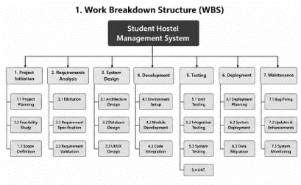
Fig 1.1: Work Breakdown Structure (WBS) – Student Hostel Management System

1.4.2 Deliverables and Milestones
Based on predictive software engineering mathematical models, the project timeline is structured around critical milestones that track the delivery of functional components.

Sequence | Deliverable | Milestone Completion
1 | Validated Project Topic, Feasibility Study, and Initial Project Plan | Week 2
2 | Finalized Software Requirements Specification (SRS) and Data Flow Models | Week 4
3 | System Design Document encompassing UML diagrams and Normalized Database Schema | Week 7
4 | Working Prototype featuring User Authentication and Core Room Allocation Logic | Week 11
5 | Complete Integrated Application featuring Billing, Mess Management, and Reporting | Week 15
6 | Final Documentation, User Acceptance Testing, and Project Submission | Week 17

1.4.3 Acceptance Criteria
The product will be considered complete and ready for institutional handover only when the following rigorous criteria are unambiguously met.
S.N. | Acceptance Criteria
1 | The application initializes and runs successfully on the target web server environment without requiring manual dependency interventions.
2 | Administrators can successfully execute complete CRUD operations on student profiles, room configurations, and staff assignments.
3 | The automated room allocation logic correctly assigns students to available beds without ever exceeding the mathematically defined maximum room capacities.
4 | The billing engine accurately calculates and generates end-of-month invoices, correctly aggregating base room rent, mess subscriptions, and applicable disciplinary penalties.
5 | Role-based access control (RBAC) securely prevents standard students from viewing global financial ledgers, peer records, or administrative dashboards.
6 | The system prevents temporal scheduling conflicts by validating proposed dates against existing check-in and check-out logs before finalizing bookings.
7 | All relational database transactions pass strict referential integrity checks.
8 | Input validation protocols actively prevent invalid or malicious data from being processed or saved.
9 | The application passes all structured unit testing, integration testing, and User Acceptance Testing (UAT) phases.
10 | Comprehensive user manuals and technical architectural documentation are finalized and formally approved by the supervisory board.

1.4.4 Project Approach
The Incremental Process Model was selected for the development of the Student Hostel Management System because of the following reasons:
1. Modular Development
The application consists of separate modules such as User Management, Room Allocation, Billing, and Maintenance Tracking. Each module can be developed independently.
2. Early Working Software
A functional version of the application is available after each increment, allowing progress to be evaluated throughout development.
3. Continuous Testing
Every completed module is tested before integrating it with the next module, helping to detect and fix defects early.
4. Easy Maintenance
Changes or improvements can be made to a specific module without affecting the entire application.
5. Reduced Development Risk
Developing the project in smaller increments minimizes the risk of major errors and makes debugging easier.
6. Better Project Management
The project can be planned, monitored, and completed in phases, making development more organized and manageable.
7. Suitable for the Project
Since the Student Hostel Management System is a web-based application with clearly defined and independent functionalities, the Incremental Process Model provides an efficient and systematic development approach.

8. Fits the project scenario
With a focused development team, a 17-week academic timeline, and clearly separable modules with stable requirements, incremental delivery provides a low-risk and well-managed path to completion.
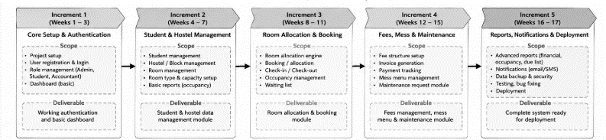
Fig 1.2: Incremental Module

1.5 Project Resourcing

1.5.1 Quality Requirements
The quality requirements the project aims to fulfil are:
• Correctness of calculations and data storage
• Reliability during normal use
• High usability through a simple interface
• Maintainable source code
• Completeness of core features
• Security of student and financial data

1.5.2 Process Requirements
The quality requirements are mapped to the Incremental Process Model as follows:
S.N. | Quality Requirement | Mapped Activity in Incremental Process | How Quality is Ensured
1 | Correctness | Testing phase of each increment | Every increment is tested individually before integration
2 | Reliability | Continuous validation across increments | Each new increment is validated against previously delivered increments
3 | Usability | Design phase of each increment | UI is reviewed and refined based on feedback from early working versions
4 | Maintainability | Modular development structure | Each increment is built as an independent module
5 | Completeness | Incremental delivery sequence | Each increment adds a clearly defined feature set

1.5.3 Method Requirements
Throughout the development of the Student Hostel Management System, a set of key framework and umbrella activities shall be followed to ensure compliant and systematic process adoption.
The framework activities, representing the core process steps carried out within every increment, are as follows:
• Communication: Requirements are clarified and validated with the project supervisor before the start of each increment.
• Planning: Tasks for each increment are scheduled and organized to maintain a structured development timeline.
• Modeling: The architecture, user interface, and database design relevant to each increment are prepared prior to implementation.
• Construction: Each module is coded and unit-tested to verify correctness before integration.
• Deployment: The completed and tested increment is integrated into the overall system and delivered as a working version.
In addition, the following umbrella activities are carried out continuously:
• Project tracking and monitoring
• Risk management
• Software quality assurance
• Software configuration management
• Documentation management

1.5.4 Resource Requirements
The successful development of the Student Hostel Management System requires the following technological, platform, environment, and human resources.
Technological Resources
• Programming Language / Framework: PHP with Laravel or Python with Django
• Frontend: HTML5, CSS3, JavaScript
• Database: MySQL or PostgreSQL
• Development Tool: VS Code / XAMPP / Docker
• Version Control: Git
Platform and Environment
• Operating System: Windows / Linux / macOS for development; Linux server for production
• Hardware: Standard desktop/laptop; institutional server or cloud instance for deployment
Human Resources
• Project Developer: 1 (Student)
• Project Supervisor: 1
• End Users for feedback: Wardens and 2–3 students

Chapter 2: Planning and Management

2.1 Project Risks

2.1.1 Identified Risk
Software engineering projects inherently carry significant threats that can compromise schedules, budgets, and the quality of the final deliverable. Proactive risk management requires identifying these factors early and quantifying their Probability and Impact on a standardized scale of 1 to 5. The Risk Priority Number (RPN) is calculated as Probability × Impact. Risks are subsequently sorted by their RPN to determine which vulnerabilities require the most urgent attention.
Risk ID | Risk Description | Category | Prob. | Impact | RPN | Priority
R1 | Unanticipated scope creep driven by evolving administrative requirements | Product | 4 | 4 | 16 | High
R2 | Relational database design flaws causing calculation failures or data corruption | Technical | 2 | 5 | 10 | High
R3 | Integration failures between room allocation and billing engine | Technical | 3 | 4 | 12 | High
R4 | Underestimation of effort for RBAC and security cryptography | Schedule | 3 | 3 | 9 | Medium
R5 | Suboptimal UI design leading to administrative friction and user rejection | Product | 2 | 4 | 8 | Medium
R6 | Hardware failure or repository compromise causing source code loss | Support | 1 | 5 | 5 | Low
R7 | Underestimated testing timelines leading to schedule slippage | Schedule | 3 | 4 | 12 | High
R8 | Gaps in input validation allowing invalid or malicious entries | Cost | 3 | 2 | 6 | Low

2.1.2 Mitigation Risk
Risk ID | Mitigation Strategy
R1 | Elicit exhaustive requirements initially and enforce a strict Change Request protocol. Lock core functionality early.
R2 | Adhere rigidly to 3NF and BCNF during initial database design; use junction tables for many-to-many relationships.
R3 | Develop a mock API bridge between allocation and billing modules early to validate data payloads.
R4 | Allocate specific buffer time in the schedule dedicated solely to security and authorization logic.
R5 | Conduct UI/UX wireframe reviews and prototype sessions with administrative staff before production frontend code.
R6 | Maintain rigorous Git commit protocols, push to remote repository daily, and keep automated local backups.
R7 | Integrate testing phases directly into each increment of the WBS rather than deferring QA to the end.
R8 | Implement strict server-side input validation during construction of each module.

2.1.3 Contingency Plan
Risk ID | Contingency Action (if risk occurs)
R1 | Halt new feature development and reduce scope to MVP; defer enhancements to future patches.
R2 | Revert to last stable schema migration, execute data cleansing, and re-run affected test suites.
R3 | Temporarily decouple modules; process financial transactions via offline batch script until bridge is repaired.
R4 | Request schedule extensions or reallocate hours from non-critical reporting modules to security core.
R5 | Switch to a simplified utilitarian layout featuring basic data tables to save development time.
R6 | Restore latest Git commit from remote repository and rebuild local environment from secured source.
R7 | Prioritize testing core acceptance criteria first; document non-critical UI bugs as known issues.
R8 | Deploy immediate hotfix for validation logic and permanently add a regression test for the failed input.

2.1.4 Risk Monitoring Plan
Risk ID | Monitoring Activity | Frequency
R1 | Compare planned vs actual progress against WBS; review pending Change Requests | Weekly
R2 | Verify database schema integrity and execute sample-data constraint checks | Every session
R3 | Monitor successful transmission rates of simulated data payloads between modules | Weekly
R4 | Track time spent per security module against WBS estimate | Weekly
R5 | Solicit informal feedback on interface usability from peers | Bi-Weekly
R6 | Audit Git commit history and verify integrity of remote backups | Weekly
R7 | Review ratio of completed versus planned test cases | Weekly / after increment
R8 | Run hostile validation test cases against every new input field | After module completion

2.2 Project Estimation and Schedule

2.2.1 Estimation Method Used
The Basic Constructive Cost Model (COCOMO 81) operating in Organic Mode was selected for effort and schedule estimation. The software operates within a familiar problem domain (hostel management), features a small focused team, and entails relatively flexible operational constraints. Using empirical algorithmic models rather than arbitrary guesswork prevents severe budget overruns and establishes a realistic baseline for project tracking.

2.2.2 Project Estimation
Based on the modular complexity of the SHMS—which encompasses extensive CRUD operations, complex algorithmic room allocations, dynamic financial billing engines, and analytical reporting—the estimated source code volume is projected at 1.6 KLOC.
Basic COCOMO 81 Formula (Organic Mode):
Effort (E) = 2.4 × (KLOC)^1.05
Development Time (T) = 2.5 × (E)^0.38
E = 2.4 × (1.6)^1.05 ≈ 3.9 Person-Months
T = 2.5 × (3.9)^0.38 ≈ 4.2 Months (approximately 17 weeks)
Suggested Team Size ≈ 1 dedicated full-time developer
Assuming a regional development cost rate of NPR 30,000 per month:
Total Cost = 3.9 × 30,000 ≈ NPR 117,000

2.2.3 Project Schedule
The project schedule is mapped using a Gantt Chart framework. This visual timeline distributes all major activities of the Student Hostel Management System across the 17-week projection. The initial weeks are front-loaded with requirement gathering and database modeling. The middle segment dictates parallel development tracks for backend logic and frontend interfaces. The final weeks are strictly reserved for integration testing, user acceptance evaluations, and final documentation.
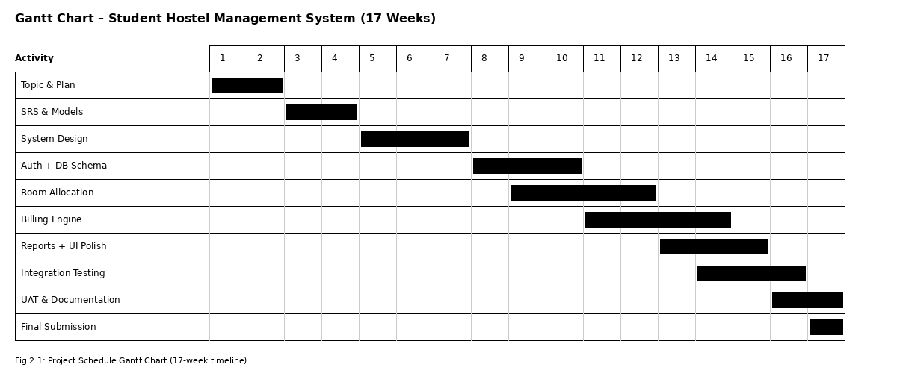
Fig 2.1: Project Schedule Gantt Chart (17-week timeline)

2.3 Configuration Management Plan

2.3.1 Change Management Plan
Any proposed change is first documented in a Change Request (CR) Log, recording the change description, reason, requester, priority, and expected impact on the schedule. Each change is reviewed against the current project scope and remaining schedule before a decision is made. Approved changes are incorporated into the next development increment. Rejected changes are recorded with reasons for future reference.

2.3.2 Version Management Plan
Git is used as the version control tool. Semantic versioning is followed (for example: v0.1, v0.5, v0.8, v1.0). Each important milestone is tagged so that stable versions can be restored if needed.

2.3.3 Release Management Plan
Release 1: Core authentication and database schema
Release 2: Room allocation and category management
Release 3: Billing engine and reporting
Final Release (v1.0): Complete system after UAT and documentation approval

Chapter 3: System Engineering

3.1 Requirements

3.1.1 Domain Requirements
The system must inherently understand and enforce the unyielding domain rules of physical hostel operations:
• Support recording of detailed student demographic and academic profiles.
• A room cannot be allocated to a number of students exceeding its defined physical capacity.
• Financial generation must accommodate dynamic variables including prorated room rent, fluctuating mess charges, and ad-hoc disciplinary penalties.
• No financial transaction, invoice, or check-in record may be hard-deleted; soft deletion must be used to preserve audit trails.
• All sensitive financial data and personal demographics must be secured using robust encryption standards.

3.1.2 Functional Requirements
Priority | Functional Requirement | Description
High | FR-01: User Authentication | Secure login with strict RBAC restricting interface and database privileges by role.
High | FR-02: Room Management | Administrators manage hostel rooms: type, capacity, base pricing, and physical location.
High | FR-03: Student Allocation | Complex room allocation handling assignment logic, waiting lists, and historical tracking.
High | FR-04: Billing and Payments | Autonomous fee management, itemized monthly invoices, and payment processing.
High | FR-05: Check-in/Check-out | Digital check-in/out with exact timestamps managing real-time room availability.
Medium | FR-06: Maintenance Requests | Students submit maintenance tickets; admins track, assign, and resolve them.
Medium | FR-07: Inventory Tracking | Track furniture and appliances tied to specific rooms or blocks.
Medium | FR-08: Reporting Analytics | Generate reports on occupancy rates, outstanding ledgers, and maintenance speeds.

3.1.3 Non-Functional Requirements
S.N. | Category | Non-Functional Requirement
1 | Usability | Administrative interface must be intuitive; staff can allocate rooms and generate invoices with minimal training.
2 | Reliability | Financial calculations must be flawless; transaction locking prevents data corruption during concurrent operations.
3 | Performance | Complex relational joins must execute and render within 2–3 seconds under normal server load.
4 | Maintainability | Source code must adhere to MVC; modules remain highly cohesive but loosely coupled.
5 | Scalability | Database architecture must support growth from hundreds to thousands of student profiles.
6 | Security | Cryptographic standards (e.g., bcrypt) protect credentials; defend against SQL injection and XSS.

3.1.4 Requirement Management Process
The engineering team employed a multi-phase requirement management process consisting of elicitation, analysis, modeling, and specification. Elicitation was conducted through communication with institutional stakeholders and questionnaires with wardens. Analysis categorized requirements into domain, functional, and non-functional parameters, resolving conflicts against the 17-week timeline by prioritizing core acceptance criteria. Modeling produced Use Case diagrams and Data Flow Diagrams. Specification documented validated requirements in the formal SRS, which was then frozen as the binding blueprint for design and construction.

3.2 Design

3.2.1 System Architecture
The system architecture of the Student Hostel Management System follows a layered architecture style. This architecture divides the application into multiple layers, where each layer has a specific responsibility and only communicates with the layer directly below it.
The layered architecture of the proposed system is shown in the figure below:

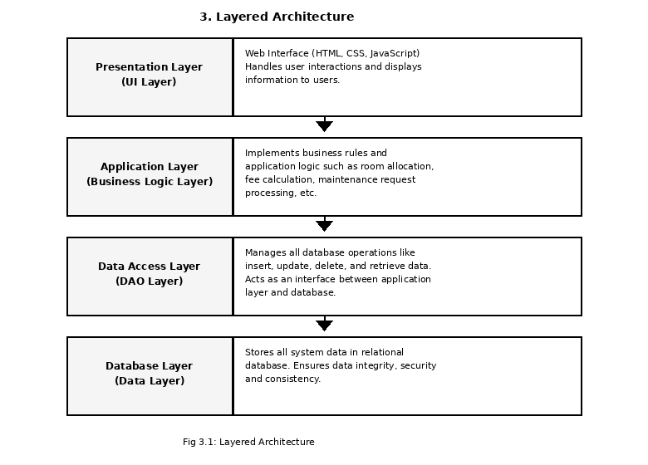
Fig 3.1: Layered Architecture
Description of Layers:
- Presentation Layer (UI Layer): Provides the web interface using HTML, CSS, and JavaScript. It handles user interactions and displays information such as dashboards, forms, and reports to Admin, Warden, and Student users.
- Application Layer (Business Logic Layer): Implements the main business rules and application logic of the system such as room allocation, fee calculation, invoice generation, maintenance request processing, and role-based authorization.
- Data Access Layer (DAO Layer): Manages all database operations like insert, update, delete, and retrieve. It acts as an interface between the application layer and the database, keeping query logic separate from business logic.
- Database Layer (Data Layer): Stores all system data in a relational database (MySQL/PostgreSQL). It ensures data integrity, security, and consistency for students, rooms, allocations, invoices, and payments.
- This layered design ensures separation of concerns, easy maintenance, and better modularity of the Student Hostel Management System application.

3.2.2 High Level Designs
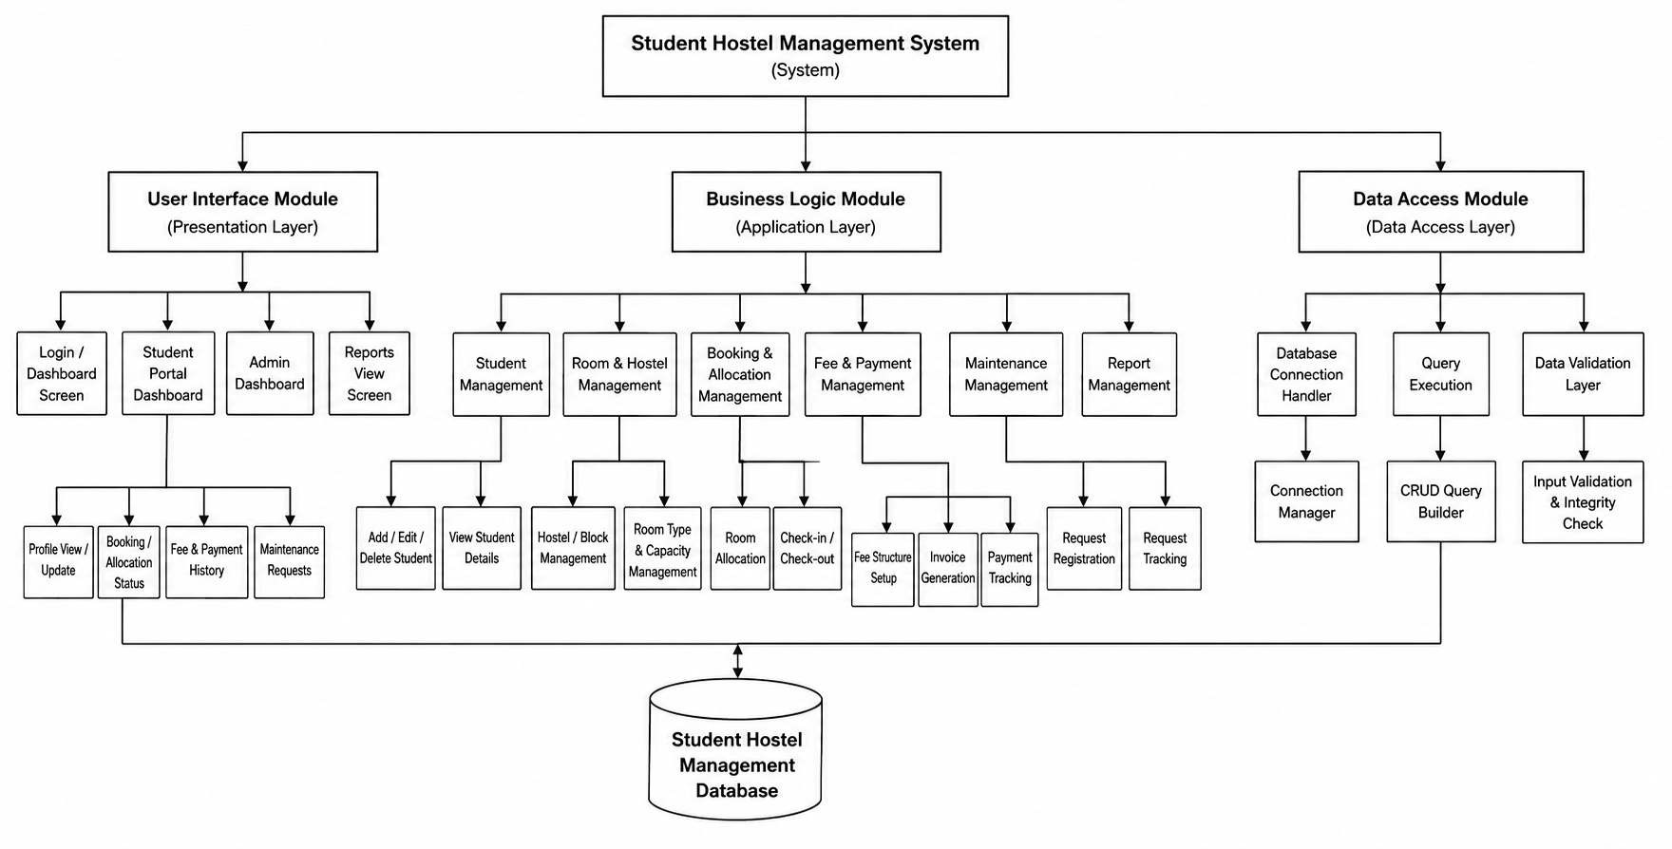
Fig 3.2: High Level Diagram
The High-Level Diagram of the Student Hostel Management System shows the overall structure of the system and how its major modules are connected. At the top is the Student Hostel Management System, which is divided into three main modules: the User Interface Module, Business Logic Module, and Data Access Module. The User Interface Module provides screens such as the login/dashboard, student portal, admin dashboard, reports, booking/allocation status, fee history, and maintenance requests. The Business Logic Module handles the core operations of the system, including student management, hostel and room management, booking and allocation, fee and payment management, maintenance, and report management.
The Data Access Module manages communication between the application and the database. It includes the database connection handler, query execution, and data validation components, which perform database connections, CRUD operations, and input/integrity checks. All information is ultimately stored in the Student Hostel Management Database, including student, room, booking, payment, and maintenance-related records. Thus, the diagram provides a high-level view of how users interact with the system, how business operations are processed, and how data is stored and retrieved.

3.2.3 Data Structure Design
The SHMS database is highly normalized up to the Third Normal Form (3NF) and Boyce-Codd Normal Form (BCNF), eliminating transitive dependencies and redundant data. Core entities are detailed below.
Entity: room_types
Field Name | Data Type | Key Constraints | Description
id | INTEGER | Primary Key (PK) | Unique identifier for the room category
name | VARCHAR(50) | NOT NULL | Category name (e.g., Single, Twin Air-Con)
capacity | INTEGER | NOT NULL | Maximum number of beds allowed
base_price | DECIMAL(10,2) | NOT NULL | Standard monthly rent applied for billing

Entity: rooms
Field Name | Data Type | Key Constraints | Description
id | INTEGER | Primary Key (PK) | Unique identifier for the physical room
hostel_block_id | INTEGER | Foreign Key (FK) | Links the room to a specific building/block
room_type_id | INTEGER | Foreign Key (FK) | References room_types.id for price and capacity
room_number | VARCHAR(10) | NOT NULL | Alphanumeric physical identifier (e.g., A-101)
status | VARCHAR(20) | NOT NULL | Real-time state (e.g., 'Available', 'Maintenance')

Entity: students
Field Name | Data Type | Key Constraints | Description
student_id | INTEGER | Primary Key (PK) | Unique database identifier
enrollment_no | VARCHAR(50) | UNIQUE, NOT NULL | Official university-issued identification
full_name | VARCHAR(100) | NOT NULL | Legal name of the student
contact_no | VARCHAR(15) | NOT NULL | Primary communication channel
admission_date | DATE | NOT NULL | Date of institutional enrollment

Entity: hostel_allocations (Junction Table)
Field Name | Data Type | Key Constraints | Description
id | INTEGER | Primary Key (PK) | Unique allocation identifier
student_id | INTEGER | Foreign Key (FK) | References students.student_id
room_id | INTEGER | Foreign Key (FK) | References rooms.id
start_date | DATE | NOT NULL | Timestamp of official check-in
end_date | DATE | NULLABLE | Timestamp of check-out or anticipated departure
status | VARCHAR(20) | NOT NULL | Lifecycle state ('Active', 'Completed', 'Cancelled')

Entity: invoices
Field Name | Data Type | Key Constraints | Description
id | INTEGER | Primary Key (PK) | Unique billing document identifier
allocation_id | INTEGER | Foreign Key (FK) | Links invoice to a room stay
issue_date | DATE | NOT NULL | Timestamp of invoice generation
subtotal | DECIMAL(10,2) | NOT NULL | Base charges before tax or penalties
tax | DECIMAL(10,2) | NOT NULL | Government or institutional levies
total_amount | DECIMAL(10,2) | NOT NULL | Final calculated sum due
status | VARCHAR(20) | NOT NULL | Payment state ('Paid', 'Unpaid', 'Overdue')

Entity: payments
Field Name | Data Type | Key Constraints | Description
id | INTEGER | Primary Key (PK) | Unique transaction identifier
invoice_id | INTEGER | Foreign Key (FK) | References invoices.id
payment_date | TIMESTAMP | NOT NULL | Exact chronological time of the transaction
amount | DECIMAL(10,2) | NOT NULL | Monetary value successfully transferred
txn_reference | VARCHAR(100) | UNIQUE | External banking or payment gateway reference

3.3 Testing

3.3.1 Test Justification
Complex relational databases and web applications require rigorous testing protocols to prevent catastrophic failures during peak institutional enrollment periods. A defect in room allocation logic could assign multiple students to a single bed. A logical flaw in the financial engine could generate invalid invoices. Comprehensive testing proves system reliability, validates business logic constraints, uncovers security vulnerabilities, and ensures data persistence under server duress.

3.3.2 Test Plan
The testing methodology integrates both black-box and white-box techniques. Black-box testing validates the system against user workflows defined in the SRS. White-box testing scrutinizes internal logic, SQL query efficiency, encryption strength, and data validation pathways. The process progresses hierarchically: unit testing, integration testing, and system testing. Pass criteria require that all core CRUD operations function without data loss, all financial arithmetic resolves with zero margin of error, and the system actively rejects hostile inputs.

3.3.3 Test Design
Test Module: Room Allocation Logic
Test ID | Scenario to Test | Execution Steps | Expected Outcome
AL-01 | Standard Allocation | Assign unallocated student to available room with capacity | Allocation entry committed; room availability decreases by 1
AL-02 | Over-capacity Rejection | Allocate student to room already at full capacity | Transaction rejected; explicit capacity error returned
AL-03 | Concurrent Conflict | Two admins allocate the final bed at the same time | First succeeds; second fails gracefully with alert

Test Module: Billing and Financial Integrity
Test ID | Scenario to Test | Execution Steps | Expected Outcome
FIN-01 | Invoice Generation | Trigger end-of-month billing for active student | Invoice populates with correct rent + mess charges
FIN-02 | Partial Payment | Input payment less than total invoice amount | Payment recorded; invoice status updates to Partial
FIN-03 | Data Persistence | Terminate DB mid multi-table financial insert | Rollback preserves previous stable state; no orphans
FIN-04 | Hostile Data Injection | Input negative value or text into payment amount | Server-side validation rejects payload before query

Chapter 4: Monitoring & Control

4.1 Monitoring & Control

4.1.1 Time Monitoring
Time monitoring of the Student Hostel Management System project is executed utilizing a Gantt Chart framework. This visual timeline tracks all major developmental phases across the projected 17-week schedule. By overlaying actual progress against the planned baseline on a weekly basis, project managers can instantly visualize whether specific increments are adhering to the critical path. Regular milestone reviews ensure that testing phases are not compressed due to preceding developmental delays..
Fig: 4.1: Gantt Chart

4.1.2 Cost Monitoring
To ensure the project adheres to COCOMO 81 estimations, the methodology incorporates Earned Value Management (EVM). EVM quantifies objective progress against consumed time and resources.
Planned Value (PV): Budgeted cost of work scheduled.
Earned Value (EV): Quantified value of work actually delivered and verified.
Actual Cost (AC): Labor hours and capital consumed to achieve that Earned Value.
Schedule Performance Index (SPI) = EV / PV
Cost Performance Index (CPI) = EV / AC
An SPI of 1.0 means the project is perfectly on schedule. A CPI of 1.0 means financial efficiency matches the plan. By tracking SPI and CPI weekly, managers gain empirical insight into deviations.

4.1.3 Control Measures
Type of Deviation | Diagnostic Cause | Control Measures
Time Delay (SPI < 1) | Modules requiring more debugging time than estimated | Enforce time-boxing; defer non-critical visual enhancements; focus on stabilizing core logic
Cost Overrun (CPI < 1) | Expanded labor hours due to misunderstood scope | Halt coding; emergency SRS review to freeze scope; restrict development to MVP features
Severe Deviation (Both) | Technology incompatibility or data model failure | Trigger contingency plans: simplify architecture, use third-party components, negotiate timeline extensions

4.2 Quality Assurance

4.2.1 QMS Selection
The Quality Management System selected as the base reference is ISO 9001, applied in a lightweight form suitable for academic projects. It provides a clear framework for defining processes, reviewing work products, and controlling quality. Its plan-do-check-act principles align with the Incremental development approach used in this project.

4.2.2 Quality Factors
Preference Order | Quality Factor | Reason for Preference
1 | Correctness | Financial calculations and allocation logic must be mathematically accurate
2 | Reliability | System must not lose data or fail during peak admission operations
3 | Security | Sensitive student and financial data require strong protection
4 | Usability | Wardens and staff may lack advanced technical literacy
5 | Maintainability | Modular MVC structure enables future team updates
6 | Performance | Reports and queries must respond within 2–3 seconds

4.2.3 Metrics for Process and Product
Metric | Description | Target / Result
Schedule Variance | Difference between planned and actual milestone dates | SV = 0 (on plan)
Effort Variance | Planned effort vs actual effort | Within COCOMO estimate
Defect Removal Efficiency | DRE = E / (E + D) | Target ≥ 95%
Requirements Coverage | % of functional requirements implemented and tested | 100%
Test Cases Passed | Percentage of planned test cases passed | 100% critical cases

4.2.4 Quality Monitoring
Quality is monitored through weekly progress reviews against the Gantt Chart, code and design reviews after each increment, unit testing after each module, integration testing after combining modules, and system/acceptance testing before final submission. Templates used include Test Case Tables, Defect Logs, Change Request Logs, and Test Summary Reports. Quality is measured against Acceptance Criteria, Functional/Non-Functional Requirements, the Test Plan, planned schedule estimates, and selected Quality Factors. Defects found during testing are fixed before moving to the next increment. Requirements are frozen after the SRS phase to avoid late changes.

Annex 1: Requirement Models
- Data Flow Diagram
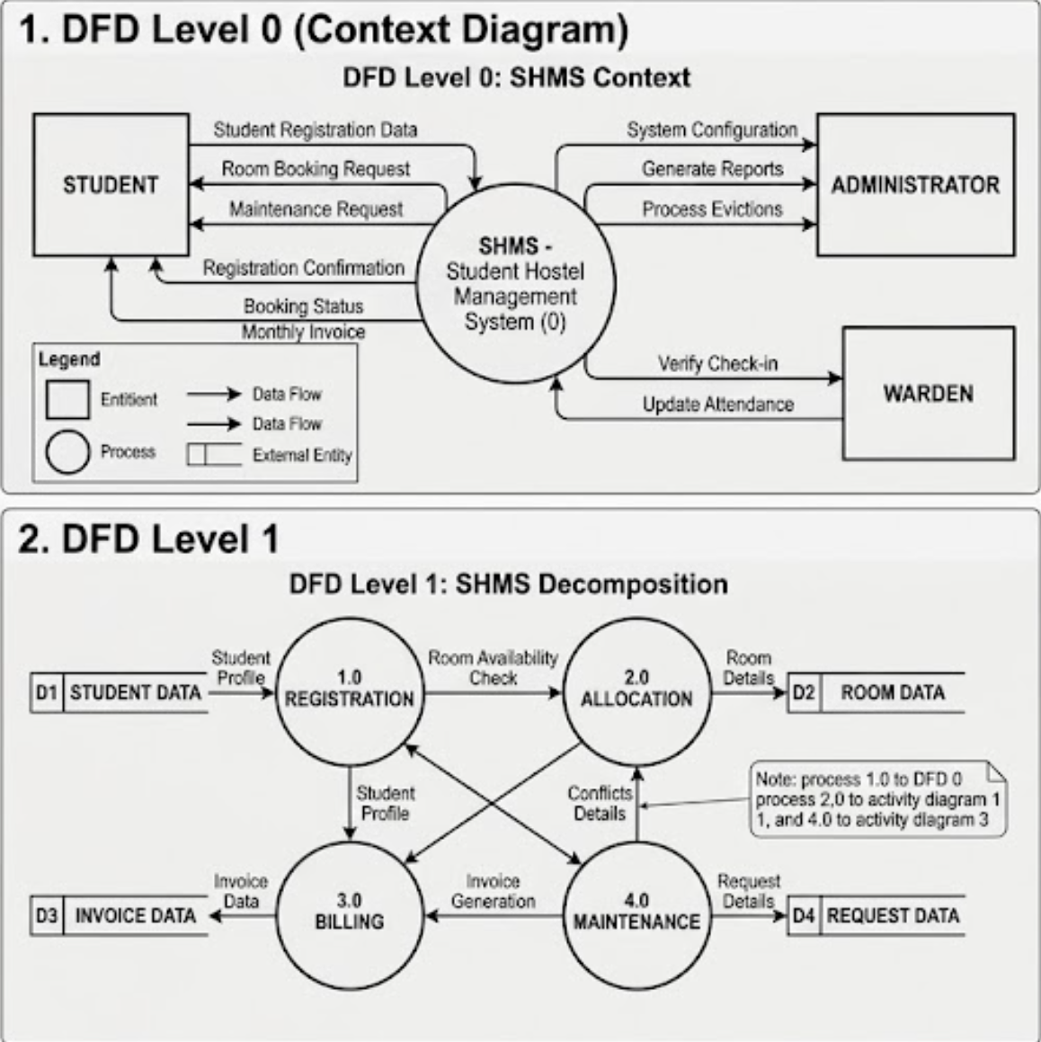

- Use Case Diagram
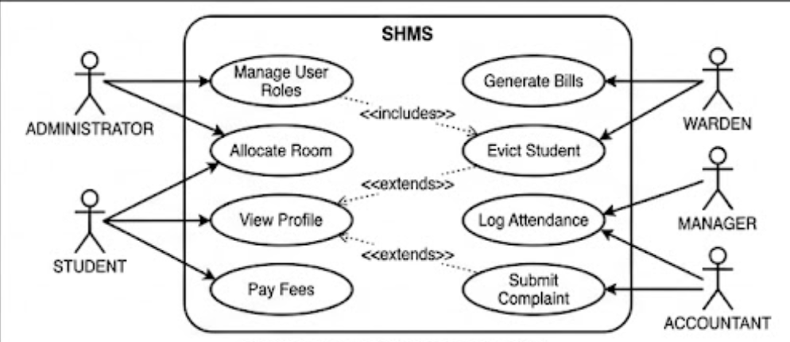
- Activity Diagram
